Name _____________________________________________________________________________
-ig word family
Directions: Choose a pig. Color it appropriately. Write the word for the picture that is on the pig. All words will end with -ig.

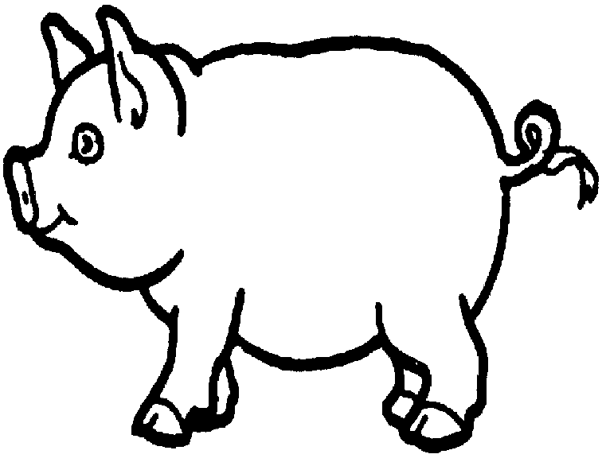
- __________________________ 4. ___________________________

- ___________________________ 5. ___________________________

- ___________________________ 6. ___________________________

Choose 1 –ig word and write a sentence.
__________________________________________________________________________________
__________________________________________________________________________________

